**SQL Assignment-1**

**1. Write a query to get a Product list (id, name, unit price) where current products cost**

**less than $20.**

**Query:**

select ProductID, ProductName ,UnitPrice from products

where UnitPrice < 20 AND Discontinued=0;

**Output:**

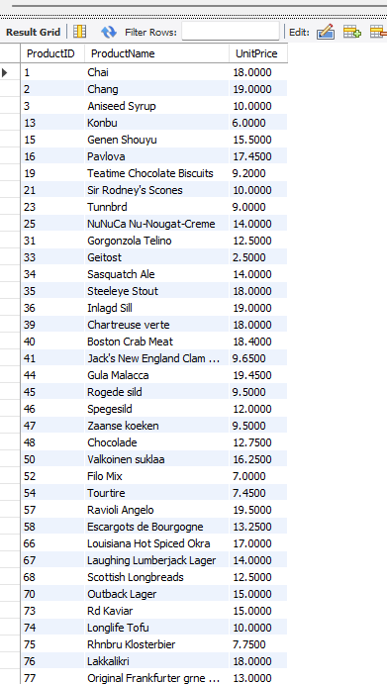

**2. Write a query to get Product list (id, name, unit price) where products cost between**

**$15 and $25**

**Query:**

select ProductID, ProductName ,UnitPrice from products

where UnitPrice between 15 and 25 ;

**Output:**

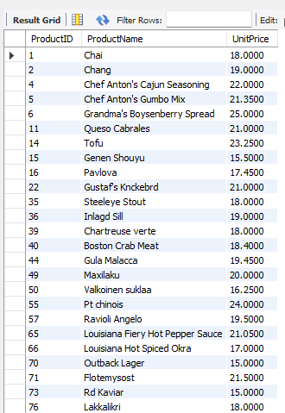

**3. Write a query to get Product list (name, unit price) of above average price.**

**Query:**

select ProductName ,UnitPrice from products

where UnitPrice > (select avg(UnitPrice) from products);

**Output:**

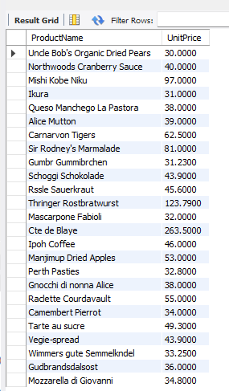

**4. Write a query to get Product list (name, unit price) of ten most expensive products**

**Query:**

select ProductName , UnitPrice from products

order by UnitPrice desc

limit 10;

**Output:**

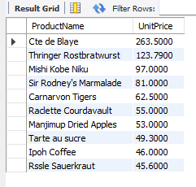

**5. Write a query to count current and discontinued products**

**Query:**

select count(ProductID) ,Discontinued from products group by Discontinued;

**Output:**

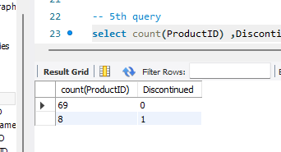

**6. Write a query to get Product list (name, units on order , units in stock) of stock is less**

**than the quantity on order**

**Query:**

select ProductName,UnitsOnOrder,UnitsInStock from products

where UnitsInStock < UnitsOnOrder;

**Output:**

